Creating Invoice Header Credit Note

|  |  |  |  |  |
| --- | --- | --- | --- | --- |
| **Ver** | **Date** | **Author** | **Comments** | **Reviewed by** |
| 1 | 16/11/2020 | Tom Bell | CRIM 0343 | TBC |
| 2 | 20/07/2021 | Tom Bell | Issue 1 and Issue 2 Added at bottom |  |

Requirements 2

Prerequisites 2

Solution Overview 2

Solution Details 2

Security 3

Companies 3

Data Migration 3

Test Steps 3

Technical Implementation 3

Requirements

The system must able to create Invoice Header Notes from the Customer Analysis screen through a dialogue box and the Invoice Header Notes screen.

Must be able to add the same Credit Note to one or many Invoices through the Customer Analysis screen.

Creating an Invoice Header Credit Note must update the Note’s Follow Up Date based on the selected Note Status.

Prerequisites

N/A.

Solution Overview

When a Credit Analyst calls a customer regarding one or many invoices, they need to be able to add a Credit Note on Invoice Header level to one or many Invoices. The Credit Analyst will add Note Text and a Note Status to the Invoice Header Credit Note.

Depending on the Note Status selected, different Follow-Up Dates will be required.

**Example Scenario:** Credit Analyst calls a customer, who has promised to pay. The Credit Analyst will go into the Customer Analysis screen (Ledger Tab) select the items that are promised to be paid. They will input note text and set the Note Status. Once saved, this data is available to be viewed from the Invoice Header Notes screen.

Solution Details

**Invoice Header Level Notes**

The below section discusses what data is needed in an Invoice Header Credit Note.

**Credit Note Status**

The below screenshot shows the data that Invoice Header Notes currently contain.

The “Text” check box column can be removed (red box in below screenshot). This column needs replaced with a “Note Text” column. This column will show the content of the Note (Note Text).

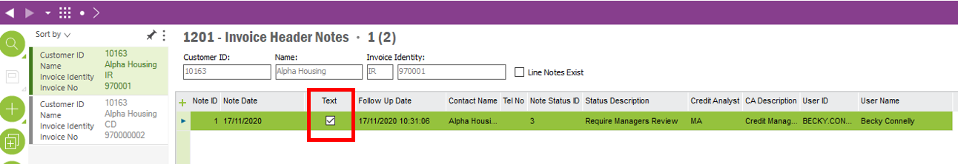

The below screenshot shows the current Note Status IDs currently in the system. These Note Statuses need to be mandatory when creating a Credit Note. (More Note Statuses are required and are discussed in more detail below).

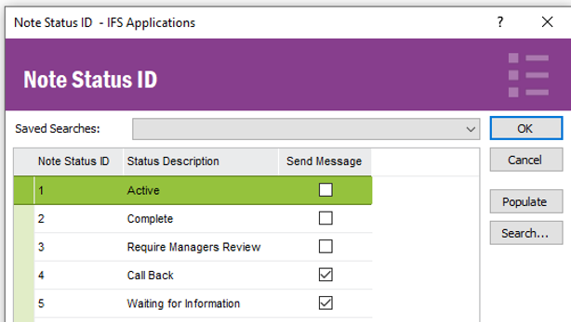

From the Invoice Header Notes screen, adding an Invoice Header Note process will not change from out of box.

However, the system needs to be able to update the “Follow Update” field based on the Note Status selected. An event needs to be configured when a Note Status is selected, it must update the “Follow Up-Date” field.

The below table shows what Note Statutes need to be added as well as how many days they effect the Follow-Up Date by.

**Example:** For example, a Note Status named “Cheque In Post” would add 5 Days to the Follow-Up Date value (Current Date + 5 Days).

The below screenshot shows the settings for the Note Statuses. Two extra columns are required in this table for the Note Status Logic to work. A “Follow-Up Date” column and a “Manual Follow-Up Date Allowed?”.

The Follow Update column will contain the number of days that need to be added to Today’s Date to calculate the total Follow-Up Date for an Invoice Credit Note.

The “Manual Follow Update Allowed” column, decides whether the follow update is automatically generated based on the Follow-Up Date values. If this box is checked, the user can simply input a manual Follow Update when creating a Credit Note.

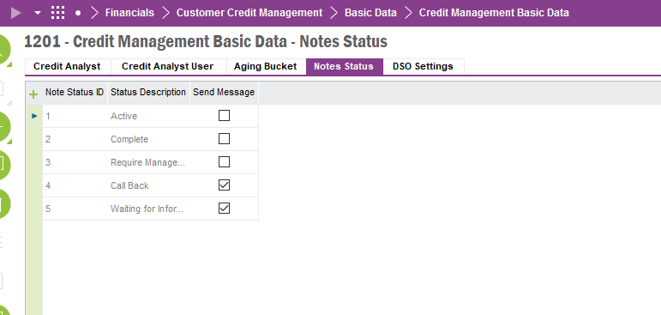

In addition to the Note Statuses that are already in the system, the below table shows the Note Statuses that are also required. As well as the Note Statuses effect on the Follow-Up Date.

**Note Status Table**

|  |  |  |  |  |
| --- | --- | --- | --- | --- |
| **Note Status ID** | **Status Description** | **Follow-Up Time** | **Allow Manual Follow-Up Date? (Tick Box)** | **Send Message** |
| 1 | Complete | N/A | N/A | Blank |
| 2 | Escalated to Credit Manager | Ask Business |  | Blank |
| 3 | Credit Manager Resolved | Ask Business | Blank | Blank |
| 4 | Cheque in Post | 5 Days | Blank. | Blank |
| 5 | Payment Promise | Blank | True. | Blank |
| 6 | BACS/Remit Received | 4 Days | Blank. | Blank |
| 7 | Additional Comment | 1 Day | Blank. | Blank |
| 8 | Copy Invoice Requested | 3 Days | Blank. | Blank |
| 9 | Message Left | 1 Day | Blank. | Blank |
| 10 | 7 Day Letter | 6 Days | Blank. | Blank |
| 11 | Credit Balance | 14 Days | Blank. | Blank |
| 12 | Payment Certificate Received | 3 Days | Blank. | Blank |
| 13 | Incoming Call | 3 Days | Blank. | Blank |
| 14 | LA Cash | 3 Days | Blank. | Blank |
| 15 | Legal | 6 Days | Blank. | Blank |
| 16 | Outgoing call/email | 3 Days | Blank. | Blank |
| 17 | Statement Requested | 3 Days | Blank. | Blank |
| 18 | Proforma | 1 Day | Blank. | Blank |
| 19 | In Query |  |  |  |

**Adding an Invoice Header Note from the Customer Analysis Screen**

**Context:** The Credit Analyst wants to make a create a Credit Note on one or many Invoices.

The below screenshot shows the Customer Credit Analysis Screen. The Credit Analyst will RMB a Customer and select “Customer Analysis”.

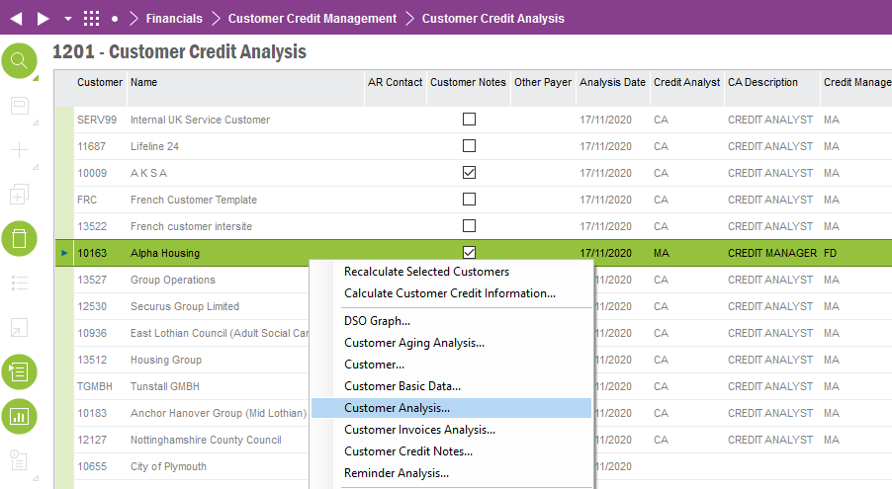

This takes the Credit Analyst to the Customer Analysis screen. Then below screenshot shows the customer Invoice Analysis screen. This is where the Credit Analyst can see the different Invoices on the Customer’s account.

Here the Credit Analyst will RMB one or many invoices, there then needs to be an RMB option “Add Credit Note to Invoice”. Clicking this will bring up a Note input dialogue box that is discussed below. This dialogue box must add an Invoice Header Note to the selected invoices.

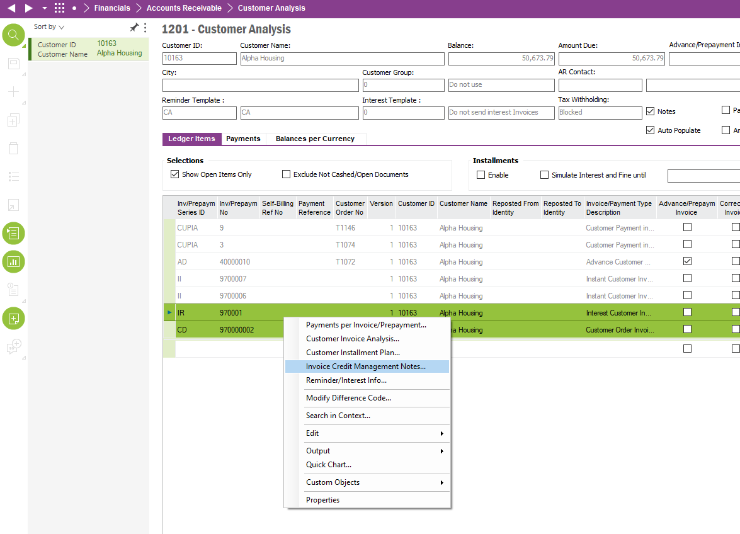

After clicking the RMB “Add Credit Note to Invoice” from the Customer Analysis (Ledger Tab) screen. This will bring up a dialogue box that will let the Credit Analyst input an Invoice Header Credit Note. If one or many invoices are selected here, the same note will be added to both Invoice Headers.

The below table shows the dialogue box fields that are required for inputting an Invoice Header Note.

|  |  |  |  |
| --- | --- | --- | --- |
| **Dialogue Box Fields** | **Field Description** | **Editable?** | **Visible in Dialogue box?** |
| Note ID | Unique Note ID | No. Auto populated based on Note ID number sequence. | Yes. |
| Date | Today’s Date | No. Auto populated. | Yes. |
| Note Text | Free text | Yes. Free text input. | Yes. |
| Follow Up Date  (DD/MM/YYYY) | Auto populated based on Note Status (unless editable).  *Follow-Up Date = Today’s Date + Follow-Up Time* | Event must take place here. If Note Status, has “Allow Manual Follow-Up Date?” box checked in the Note Status table. Then Follow Update is editable. Else, populate field with (Today’s Date + Follow Up Time). | Yes. |
| Contact Name | Contact Name of Customer | No. Auto populated. | Yes. |
| Tel. No. | Customer Tel. No. | Yes. | Yes. |
| Note Status ID | Status ID | Yes. Selectable from a drop-down list, list must also contain corresponding Note Description. | Yes. |
| Note Status Description | Status Description | No. Auto populated from Note Status ID. | Yes. |
| Credit Analyst | Credit Analyst | No. Auto populated with current Credit Analyst. | No. |
| Credit Analyst Description | Credit Analyst Description | No. Auto populated with current Credit Analyst Description. | No. |
| User ID | User ID | No. Auto populated with current User ID. | No. |
| User Name | User Name | No. Auto populated with current User Name. | No. |

Once the note dialogue box is finalised, the note data is saved in the “Invoice Header Notes” screen. As shown in the screenshot below.

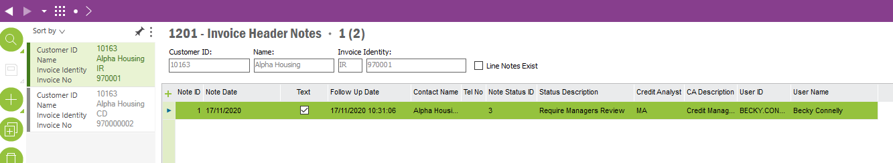

**Issue 1 – Bulk Update Follow Up Date Refresh**

“Bulk Update Notes (Invoice Header Notes/Cust Analysis screen) – A refresh of the Follow Up date needs to be automatically ran before the Bulk Update is executed. This will prevent old dates being Bulk Updated to other Invoices.”

Below is walk through of the current solution. When Bulk Updating Invoice Credit Header Notes the basic process that was developed is as follows.

1. RMB one or many invoices and select “Select for Bulk Update”. This marks a checkbox called Bulk Update. These two records can now have the same Invoice Header Note added to them.

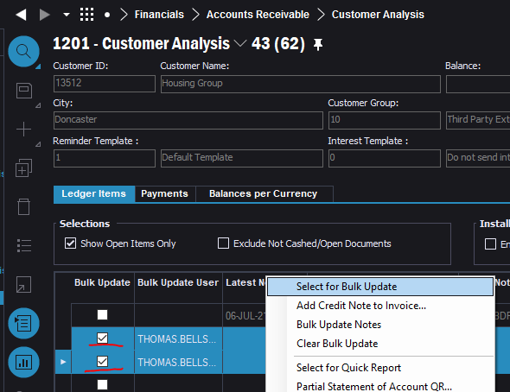

1. Select Add Credit Note to Invoice

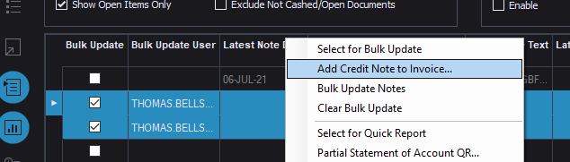

1. Create a Note in one of the Invoices and save the Note.

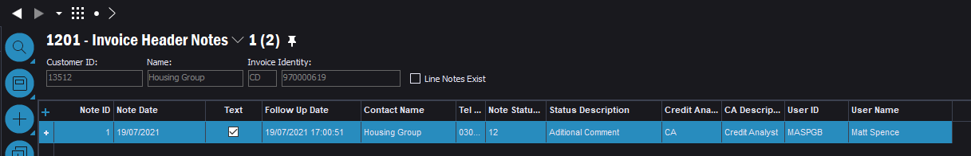

1. Then click “Bulk Update Notes”

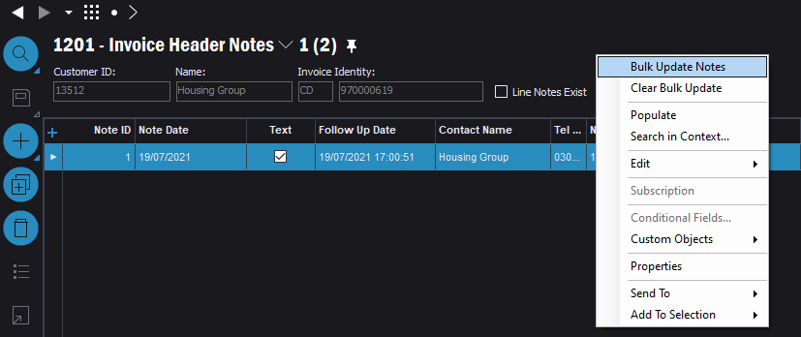

1. Now the same note is on both invoices as per below.

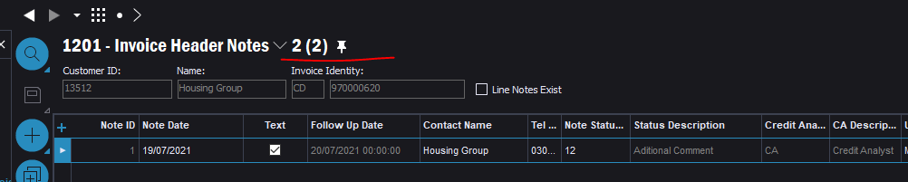

**CHANGE**

Between steps 3 and 4 when the note is saved, please can the “Update Follow Update” event be ran automatically for the Invoice Header Note that was just created?

Doing so will then have the most up to date Invoice Header Note when the Bulk Update is ran.

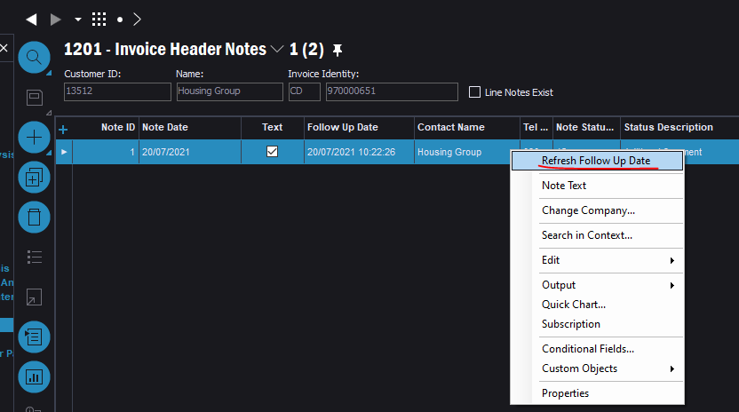

**Issue 2 – Editable Manual Follow Up Date**

The Basic Data here should allow a user to add a Manual Follow-Up date for certain Note IDs such as Payment Promise.

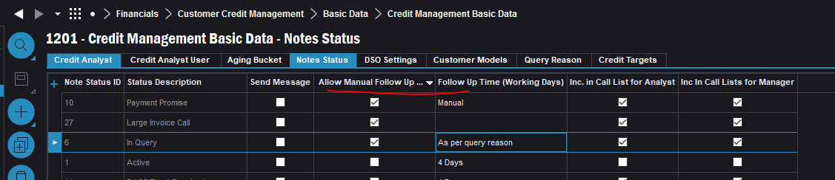

However, I cannot edit the Follow Update field when a Manual Follow Update Field is selected.

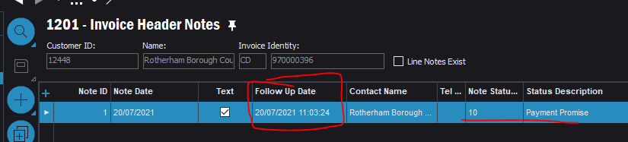

If the Note Status Basic Data has Allow Manual Follow Update TRUE then a user should be able to input a date manually in the Follow Update field in the Invoice Header Notes screen.

# Technical.

Field Definitions.

<New Field/CLU Definition>

|  |  |  |  |  |  |  |
| --- | --- | --- | --- | --- | --- | --- |
| New DB Object Name | DB Object Item/Field Names | Item Description | Item Data Type | Item Syntax | Calculation Spec, if Derived | LOVs/Enums/Is Mandatory? |
|  |  |  |  |  |  |  |
|  |  |  |  |  |  |  |
|  |  |  |  |  |  |  |
|  |  |  |  |  |  |  |
|  |  |  |  |  |  |  |
|  |  |  |  |  |  |  |
|  |  |  |  |  |  |  |
|  |  |  |  |  |  |  |
|  |  |  |  |  |  |  |
|  |  |  |  |  |  |  |
|  |  |  |  |  |  |  |
|  |  |  |  |  |  |  |

Security

<Define security controls> (Who needs access to this and will it be restricted from any other users etc)

|  |  |
| --- | --- |
| **Role** | **Permissions** |
| Finance Manager | Create Permissions |
| Credit Manager | Create Permissions |
| Credit Analyst | Create Permissions.  Cannot create a note with Status 3 (Credit Manager Resolved). |

Companies

Applies to the following companies. All.

|  |  |
| --- | --- |
| **Company** | **Required (Y/N)** |
| 1201 | Y |
| TBC |  |
|  |  |

Data Migration

<Describe any data migration impacts this development may have – i.e additional data to be migrated>

Test Steps

<Steps that needs to be taken to test this change. Please provide expected results> Updated post solution.

|  |  |  |
| --- | --- | --- |
| **No** | **Script\Test Steps** | **Expected Result** |
| 1 | On Invoice Header Screen and select add a note. | See Note Text Field in line of Note. Open list of Note Status. See updated Follow Up Date based on selected Note Status. |
| 2 | On Customer Analysis Screen (ledger tab) select one or many items and RMB, see “Add Invoice Credit Note” option. | Once selected, opens a dialogue box with the desired fields to input an Invoice Header Note. Once saved, this data is visible in the Invoice Header Notes screen. |
|  |  |  |
|  |  |  |
|  |  |  |
|  |  |  |

Technical Implementation

This implementation contains following custom objects  
  
Custom LUs

* InvoiceHeaderNotesExt
* LedgerItemExt
* Query Reason

Custom Menus  
  
Customer Analysis Window

* Select for Bulk Update
* Add Credit Note to Invoice…
* Bulk Update Notes
* Clear Bulk Update

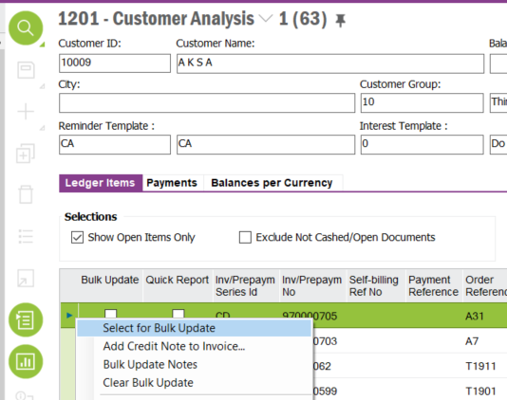

Invoice Header Notes Window

* Refresh Follow Up Date
* Bulk Update Notes
* Clear Bulk Update

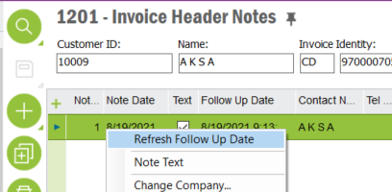

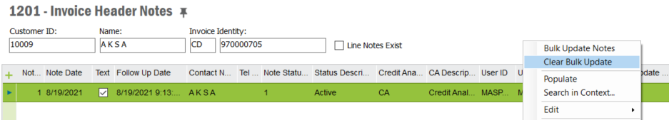

Custom Tabs

Query Reason  
  
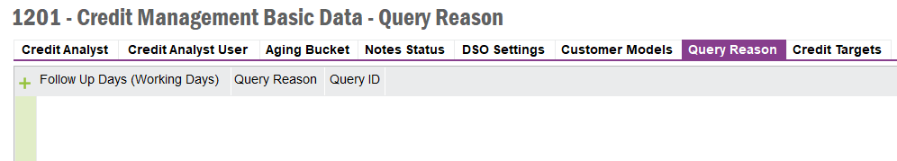

**Custom Fields**  
  
Invoice Header Notes LU  
  
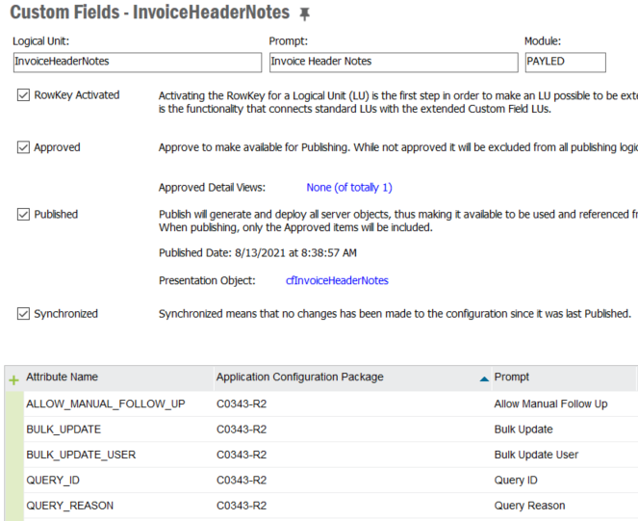  
  
Credit Notes Status LU

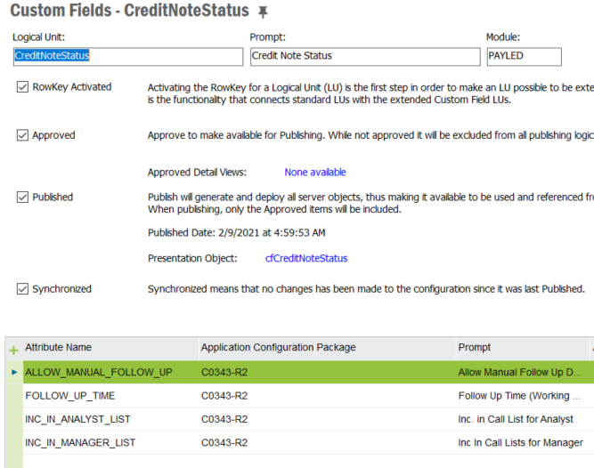

Ledger Item LU

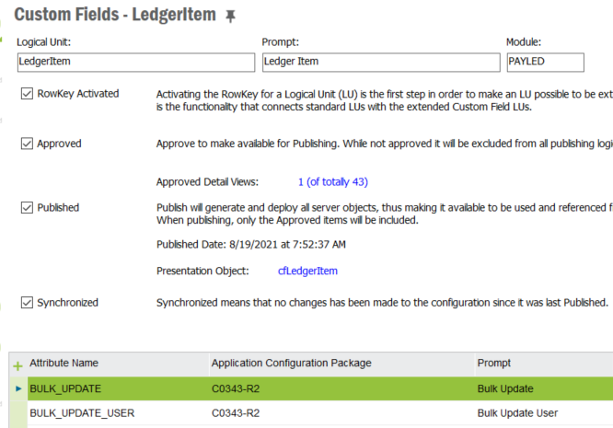

**Conditional Fields**

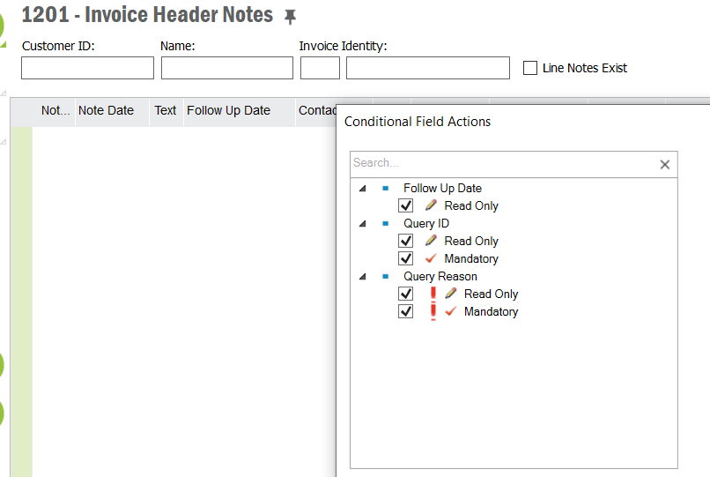

**Custom Events**

* INVOICE_HEADER_NOTE_DATE
* INVOICE_HEADER_NOTE_DATE2
* INVOICE_HEADER_NOTES_EXT